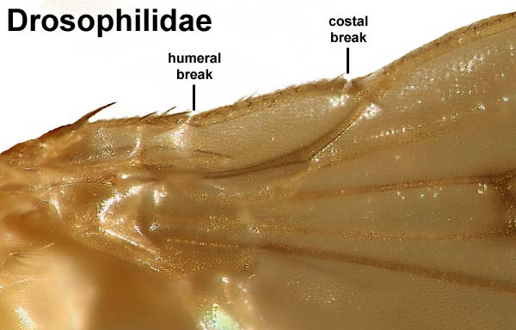

http://www.entomology.umn.edu/museum/links/coursefiles/JPEG%20images/Diptera%20web%20jpeg/Brachycera/Drosophilidae/Drosophila-wing.jpg

http://www.entomology.umn.edu/museum/links/coursefiles/Brachycera%20characters.html

